**Phase 6: User Interface Development**

1. Building Lightining app

Navigation:

Go to **Setup → App Manager → New Lightning App**

1. Settings the home page where there will be a dashboard

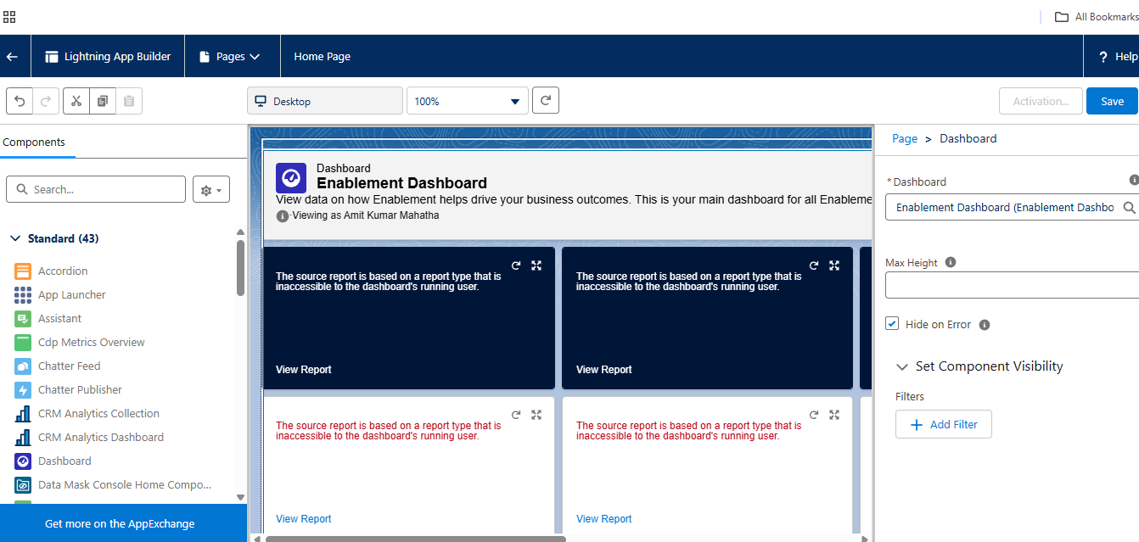

3.Building lightning app

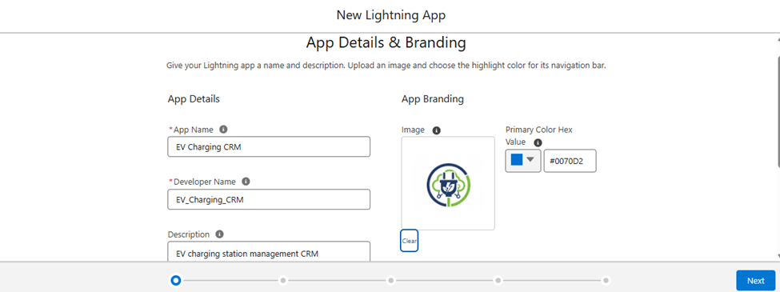

4. Utility bar setup (shown in the bottom)

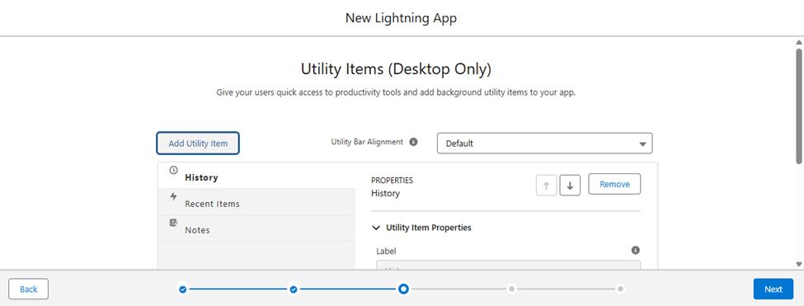

5.Record pages

Booking -> two types of record first “one time booking” and another “Subscription based”

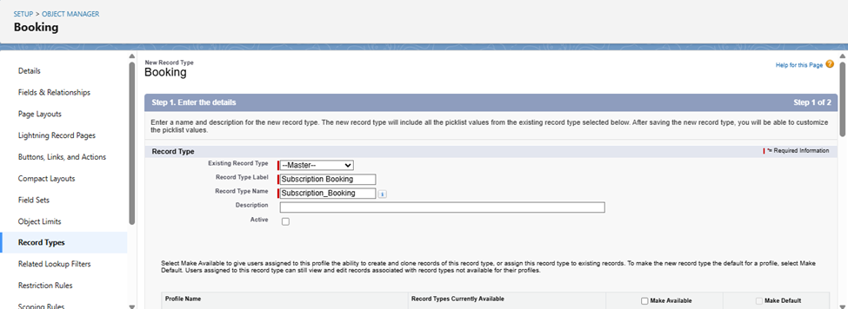

Maintenance record type

